Spectrometer Logger

Goal
The spectrometer logger is a python-based logging script to record and monitor the devices status all day.

Python Requirements
OS: Windows
Minimum Version: Python 3.6
Required Package: pyvisa

Installation

Download from GitHub
https://github.com/Bridge12Technologies/pyB12LOG

After downloading, type the command in terminal window:
pip install -e pyB12LOG

Pip Install
Pip install pyB12LOG

General Usage of pyB12logger
The pyB12logger is used to log data/status from instruments. When first start the logger, some configuration files and log folders will be created automatically. To start or control the logger, type the following command in terminal window. Please be advised that the options of startup and desktop are only available in the administration mode.

pyB12logger [-h] [-desktop {True,False}] [-startup {True,False}] [-debug {True,False}] [{start,stop}]

Arguments/Options | Description
{start, stop} | To start or stop logger. If no arguments or options present, it will be set to ‘start’
-h --help | Show help message
-desktop {True, False} | Create desktop icons
-startup {True, False} | Enable or disable pyB12logger running when startup
-debug {True, False} | Start pyB12logger with console window

Log Data and Debug Log
The device logging files are in C://Users/Public/B12TLOG.The format of file name is ‘log_YYYYMMDDHHMM.csv’. The file size is less than 100 kB by default. The debug_log.txt is saved in this folder.
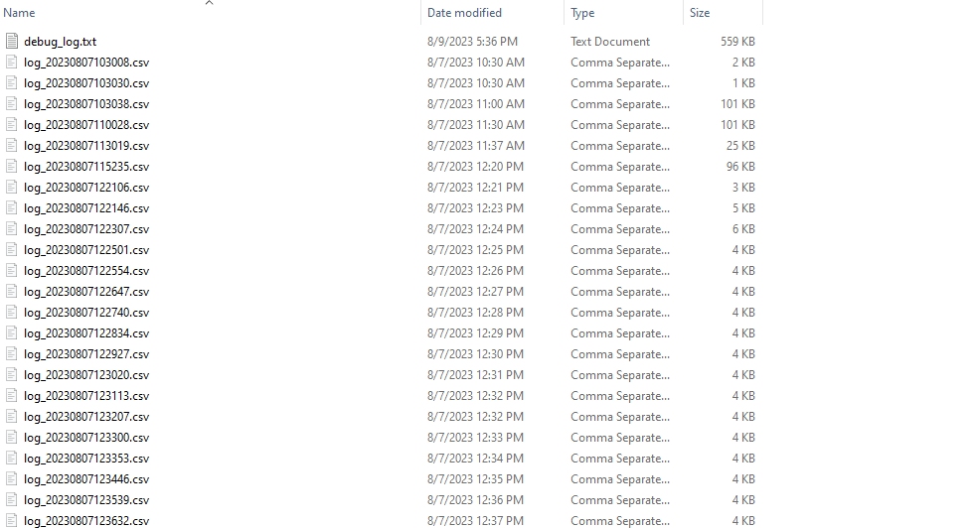

Logger Configuration
The logger configuration file is in C://Users/Public/B12TLOG_Config/config.cfg. Users can change the log interval, maximum file size and the location to save logged files.
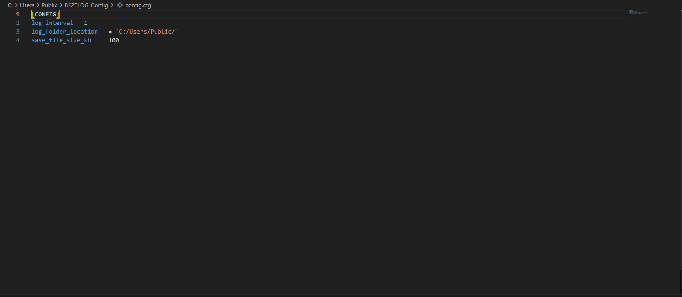

Device Commands
The commands are saved in C://Users/Public/B12TLOG_Config/command.cfg. The format of this file is:
[DEVICEMODELNUMBER]
Item1 = command1
Item2 = command2
…
The logger will read command.cfg and send commands automatically.
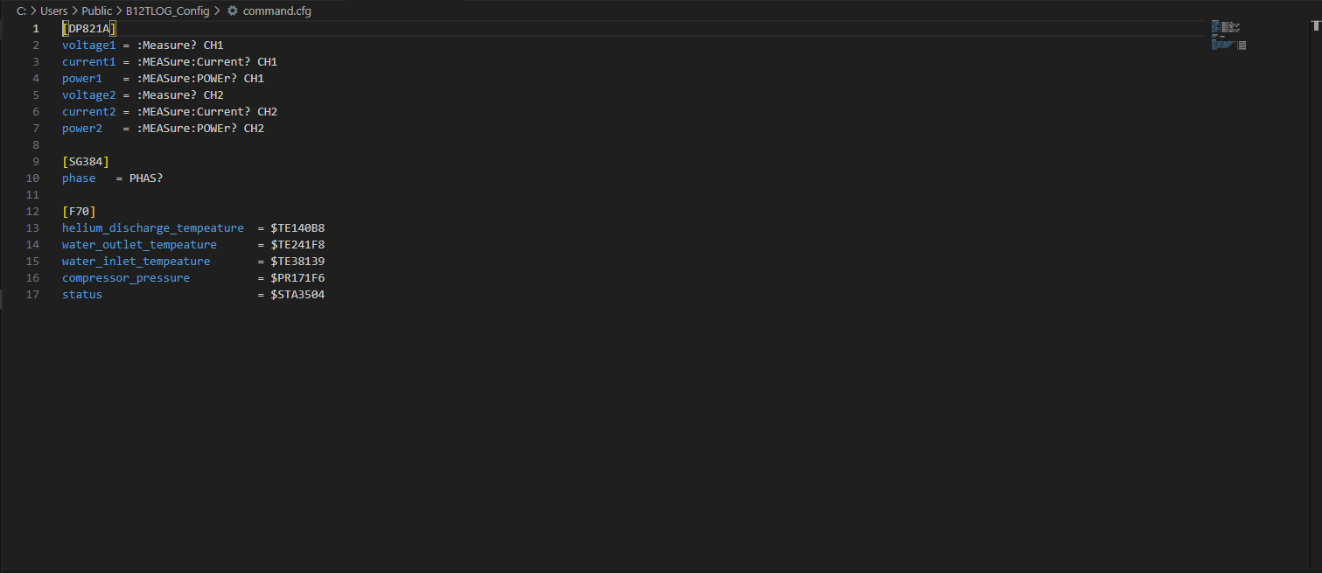

Device Configuration
The commands vary among different devices. The logger can do device auto detection, but the auto detection can fail. It will save all the port devices information to the logged files folder (C://Users/Public/B12TLOG_Config/device_config.cfg by default). When logger is initialized, the file is created automatically. The information contains:
Item | Changeable | Description
Device Address | No | The comport address on the computer.
Device Status | Yes | Enable/Disable of device serial communication. If the device cannot be talked to, the device status is False.
Device Manufacturer | Yes | The manufacturer of devices. It is extracted from the query(‘*IDN?’). Sometimes it is wrong.
Model Number | Yes | The model number of devices. It is extracted from the query(‘*IDN?’). Sometimes it is wrong. Please make sure this is the exact the same as in the command.cfg.
Serial Number | Yes | The serial number of devices. It is extracted from the query(‘*IDN?’).
Baud Rate | Yes | By default, it is 9600
Id Command | Yes | The command that is sent to devices to ensure the device serial communication is working properly. By default, it is ‘*IDN?’ from IEEE-488
Termination | Yes | The termination of read/write.
Split Sign | Yes | The sign to split the data from device.
Data Index | Yes | The return data index after being split. For example, if data return ‘$ID1,017,000,000’, split sign is comma and ‘017’ is the data to log, then the data index should be 1.
Flow Control | Yes | The type of flow control used by the transfer mechanism.
Parity | Yes | Parity type to use with every frame transmitted and received on a serial session:  Parity.none = 0  Parity.odd = 1  Parity.even = 2  Parity.mark = 3  Parity.space = 4
Stop Bits | Yes | The number of stop bits that indicate the end of a frame on a serial resource:  StopBits.one = 10  StopBits.one_and_a_half = 15  StopBits.two = 20

Please update the device_config.cfg file so that the devices can be talked to. When the file is created, the default device status is False. Users need to make it to True so that logger will try to talk to the device. If the device cannot be talked to, this setting will be forced to False again.

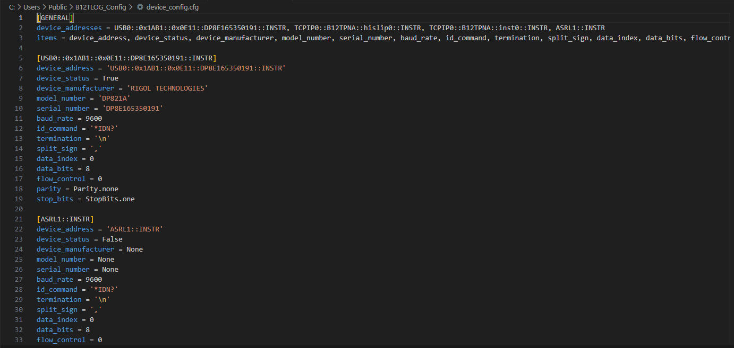

pyB12plotter
The pyB12plotter is used to plot historical data in real-time or static way. To start the plotter, type one of the following commands to start.

Commands | Description
pyB12plotter | Start the plotting
pyB12plotter_debug | Start the plotting with console

Usage of pyB12plotter
There are two slider bars, and each has one reset button.
The ‘Zoom’ slider bar controls the real-time plots. It can zoom in towards to latest time.
The ‘File’ slider bar changes the plot from real-time to static. It helps users to choose what file to plot in static. If the slider bar is left-most, it plots the real-time data. Use the reset button to switch the plot to real-time.
Users can check the buttons on the left side to select the data to plot.
